**CREATION AND EVALUATION OF A MULTIPLE REGRESSION MODEL**

1. **Description and source of dataset**

https://data.wa.gov/Transportation/Electric-Vehicle-Population-Data/f6w7-q2d2

This dataset shows the Battery Electric Vehicles (BEVs) and Plug-in Hybrid Electric Vehicles (PHEVs) that are currently registered through Washington State Department of Licensing (DOL).

Data includes Battery Electric Vehicles and Plug-in Hybrid Electric Vehicles registered as of June 30, 2023.

1. **Objectives of the Analysis**

This analysis aims to develop a predictive model that can accurately estimate the ‘electric range’ dependent variable based on the values of multiple independent variables ('Model Year', '2020 Census Tract', 'Base MSRP'). The primary objective is to understand the relationships between the independent variables and the dependent variable to make accurate predictions about future outcomes.

1. **Descriptive statistics for each variable**

|  |  |  |  |
| --- | --- | --- | --- |
| **Ser** | **Feature** | **Description** | **Data type** |
|  | VIN (1-10) | The 1st 10 characters of each vehicle's Vehicle Identification Number (VIN). | Text |
|  | County | This is the geographic region of a state that a vehicle's owner is listed to reside within. Vehicles registered in Washington state may be located in other states. | Text |
|  | City | The city in which the registered owner resides. | Text |
|  | State | This is the geographic region of the country associated with the record. These addresses may be located in other states. | Text |
|  | Postal Code | The 5 digit zip code in which the registered owner resides. | Number |
|  | Model Year | The model year of the vehicle, determined by decoding the Vehicle Identification Number (VIN). | Number |
|  | Make | The manufacturer of the vehicle, determined by decoding the Vehicle Identification Number (VIN). | Text |
|  | Model | The model of the vehicle, determined by decoding the Vehicle Identification Number (VIN). | Text |
|  | Electric Vehicle Type | This distinguishes the vehicle as all electric or a plug-in hybrid. | Text |
|  | Clean Alternative Fuel Vehicle (CAFV) Eligibility | This categorizes vehicle as Clean Alternative Fuel Vehicles (CAFVs) based on the fuel requirement and electric-only range requirement in House Bill 2042 as passed in the 2019 legislative session. | Text |
|  | Electric Range | Describes how far a vehicle can travel purely on its electric charge. | Number |
|  | Base MSRP | This is the lowest Manufacturer's Suggested Retail Price (MSRP) for any trim level of the model in question. | Number |
|  | Legislative District | The specific section of Washington State that the vehicle's owner resides in, as represented in the state legislature. | Number |
|  | DOL Vehicle ID | Unique number assigned to each vehicle by Department of Licensing for identification purposes. | Number |
|  | Vehicle Location | The center of the ZIP Code for the registered vehicle. | Text |
|  | Electric Utility | This is the electric power retail service territories serving the address of the registered vehicle. | Text |
|  | 2020 Census Tract | The census tract identifier is a combination of the state, county, and census tract codes as assigned by the United States Census Bureau in the 2020 census, also known as Geographic Identifier (GEOID). | Number |

1. **List of the independent/dependent variables**
2. Model Year (independent variable) - Ratio
3. 2020 Census Tract (independent variable) - Nominal
4. Base MSRP (independent variable) - Ratio
5. Electric Range (dependent variable) - Ratio
6. **Results**

I performed multiple regression model on the dataset with three independent and one dependent variable as mentioned above.

Predicted ‘Electric Range’ = 85.88487377 for ‘Model Year’ = 2019, ‘2020 Census Tract’ = 53061053802, ‘Base MSRP’ = 50000.

1. **Plots and tests**

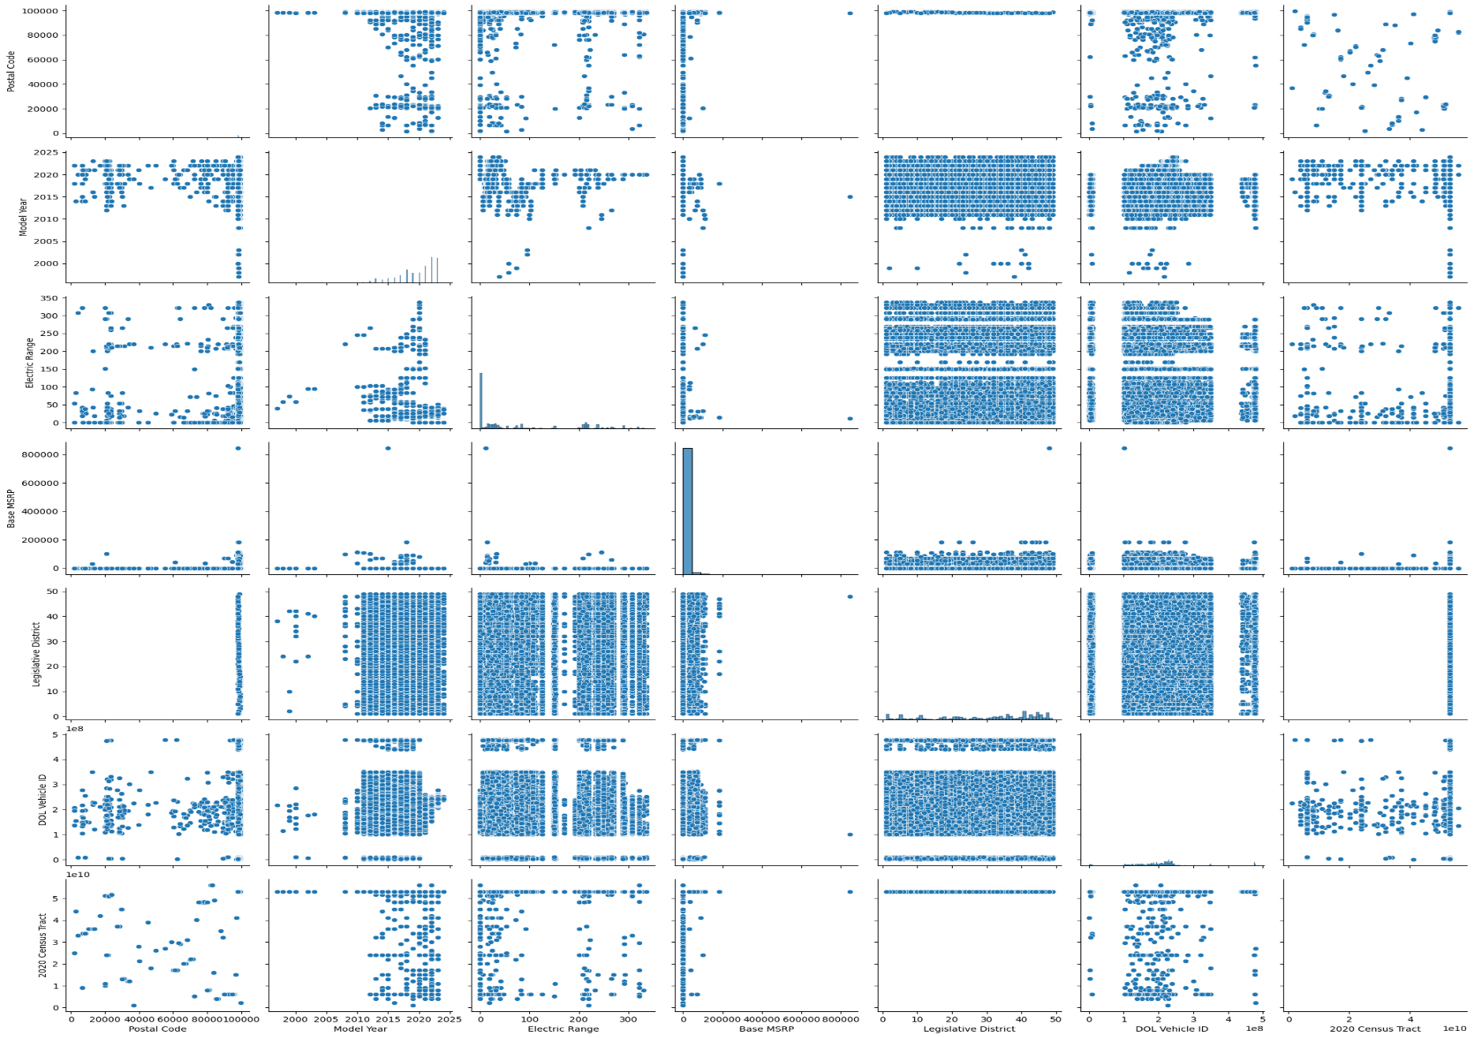

**Figure 1:** Visualizing the relationships between features using pair plots.

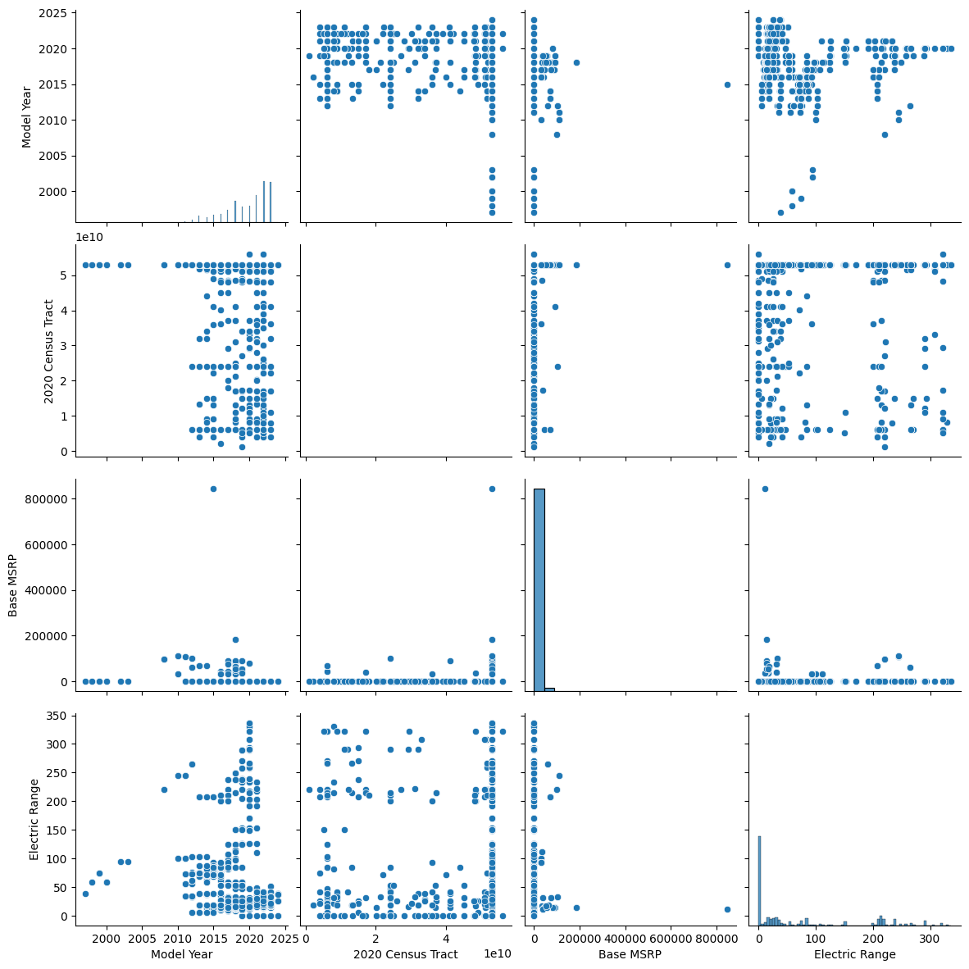

**Figure 2:** Visualizing the relationships between independent and dependent features using pair plots.

1. **Decisions and conclusions**
2. **Model Coefficients:** By analyzing the regression coefficients of the independent variables, you can determine the strength and direction of their relationship with the dependent variable (Electric Range). Positive coefficients indicate a positive relationship, while negative coefficients indicate a negative relationship. The magnitude of the coefficients reflects the extent of influence on the Electric Range.
3. **Significance of Variables:** Evaluating the statistical significance of the independent variables helps identify which factors have a significant impact on Electric Range.
4. **Importance of Model Year:** The coefficient of the Model Year variable can provide insights into how the electric range of vehicles has changed over time. A positive coefficient would suggest that newer model years tend to have a higher electric range, indicating advancements in battery technology or vehicle design. This finding could inform decisions related to promoting the adoption of newer electric vehicle models.
5. **Impact of Census Tract:** The coefficient associated with the 2020 Census Tract variable reflects how the geographic location (census tract) influences the electric range of vehicles. A statistically significant coefficient would indicate that certain areas have a higher or lower electric range on average. This finding could be used to identify geographical factors that impact electric vehicle adoption and guide decisions regarding infrastructure development and targeted incentives in specific regions.
6. **Influence of Base MSRP:** The coefficient of the Base MSRP variable provides insights into how the initial price of electric vehicles affects their electric range. This information could help understand the relationship between cost and electric range and guide decisions regarding pricing strategies, subsidies, or incentives for affordable electric vehicles.

**CREATION AND EVALUATION OF A LOGISTIC REGRESSION MODEL**

1. **Description and source of dataset**

https://catalog.data.gov/dataset/logistic-regression-samples-forest-harvest-patterns-on-private-lands-in-the-cascade-mounta

In this dataset Forest harvest (i.e., disturbance) events were randomly sampled from forest-to-disturbance conversion patches in each year (1985–2012). A total of 2486 samples were obtained, with 952 selected from the unharvested areas and 1534 selected for harvested areas. Approximately 50 random samples were collected for each year in the time series; however, for a few years fewer than 20 harvest samples were collected.

1. **Objectives of the Analysis**

The possible objective of performing logistic regression on the Forest harvest patterns on private lands in the Cascade Mountains, Washington, USA dataset is to predict the probability of forest harvest on private tracts throughout the Cascade Mountains based on biophysical and anthropogenic factors.

1. **Descriptive statistics for each variable**

|  |  |  |  |  |
| --- | --- | --- | --- | --- |
| **Ser** | **Feature** | **Description** | **Data type** | **Variable type** |
|  | Compound Topographic Index | Uses slope and runoff to approximate hydrologic catchment | Float | Independent |
|  | National Elevation Dataset | Cell elevation values | Float | Independent |
|  | Slope | Derived from National Elevation Dataset | Float | Independent |
|  | Average Water Content | SSURGO description of water content in soils | Int | Independent |
|  | Soil Organic Content | SSURGO description of organic content in soils | Int | Independent |
|  | Soil Moisture Content | SSURGO modiﬁed description of soil moisture | Int | Independent |
|  | Distance to Streams | Distance from closest streamline hydrography feature | Float | Independent |
|  | Distance to Water | Distance from closest water polygon hydrography feature | Float | Independent |
|  | January Minimum Temperature | The lowest recorded January temperature by location—1971 to 2000 | Float | Independent |
|  | July Maximum Temperature | The highest recorded July temperature by location—1971 to 2000 | Float | Independent |
|  | Average Temperature | Average annual temperature—1971 to 2000 | Float | Independent |
|  | Average Precipitation | Average annual precipitation—1971 to 2000 | Float | Independent |
|  | Distance to Railroads | Distance from closest railroad line feature | Float | Independent |
|  | Distance to Roads | Distance from closest road line feature | Float | Independent |
|  | Distance to All Cities | Distance from closest city point feature | Float | Independent |
|  | Distance to Cities (25,000 or more) | Distance from closest city point feature | Float | Independent |
|  | Distance to Cities (100,000 or more) | Distance from closest city point feature | Float | Independent |
|  | Housing Density | 2000 US Census block housing density | Float | Independent |
|  | Population Density | 2000 US Census block population density | Float | Independent |
|  | Stand Age | Interpolated forest age from the USDA Forest Inventory and Analysis | Int | Independent |
|  | Maximum EVI Greenness | Maximum Enhanced Vegetation Index in June August of year prior to disturbance | Float | Independent |
|  | Mean EVI Greenness | Mean Enhanced Vegetation Index in June-August of year prior to disturbance | Float | Independent |
|  | Standard Deviation EVI Greenness | Annual standard deviation of Enhanced Vegetation Index in year prior to disturbance | Float | Independent |
|  | Absence/ Presence | Label | Int | Dependent |

1. **Results**

I performed logistic regression model on the dataset.

Accuracy achieved = 63.0522%.

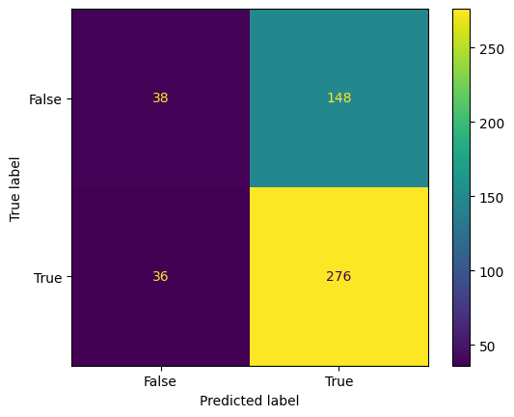

**Figure 3:** Confusion matrix

1. **Plots and tests**

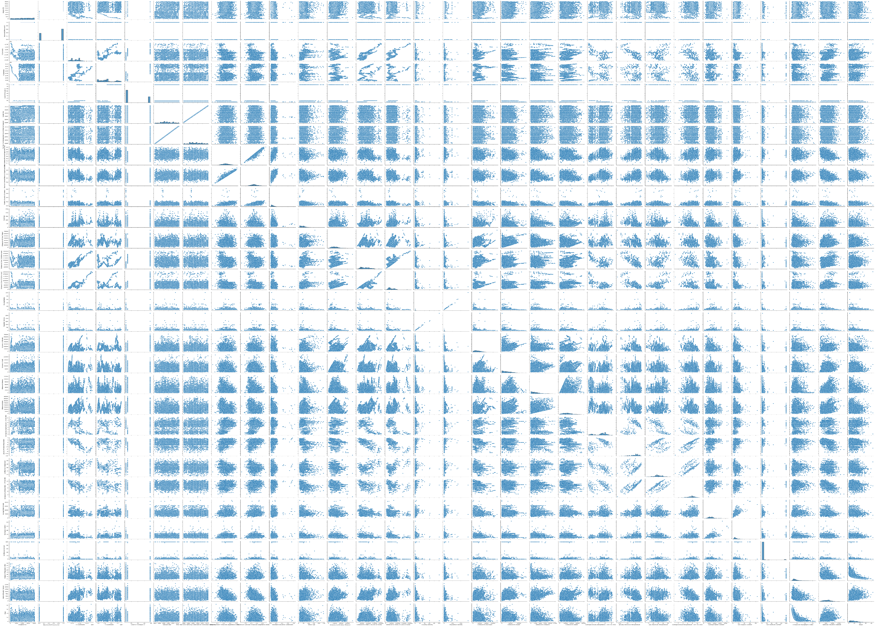

**Figure 4:** Visualizing the relationships between features using pair plots.

1. **Decisions and conclusions**

The analysis was conducted using logistic regression to examine the forest harvest patterns on private lands in the Cascade Mountains, Washington, USA dataset. The logistic regression model aimed to identify the significant predictors that influence the likelihood of specific forest harvest patterns. The following variables were included as predictors:

1. **Topographic and Elevation Factors:** The variables Compound Topographic Index and National Elevation Dataset provided insights into the role of topography and elevation in forest harvest decisions. The analysis revealed whether higher or lower values of these variables were associated with specific harvest patterns.
2. **Climate Factors:** Several climate variables, including January Minimum Temperature, July Maximum Temperature, Average Temperature, and Average Precipitation, were examined. The coefficients of these variables indicated whether particular climate conditions influenced the likelihood of certain forest harvest patterns.
3. **Soil and Water Characteristics:** Variables such as Average Water Content, Soil Organic Content, Soil Moisture Content, Distance to Streams, and Distance to Water were considered to understand the impact of soil and water characteristics on forest harvest patterns.
4. **Human Influence:** The analysis included variables such as Distance to Railroads, Distance to Roads, Distance to All Cities, Distance to Cities (25,000 or more), Housing Density, and Population Density. These variables provided insights into the influence of human proximity and infrastructure on forest management decisions.
5. **Vegetation and Land Characteristics:** Variables such as Stand Age, Maximum EVI Greenness, Mean EVI Greenness, and Standard Deviation EVI Greenness were examined to assess their relationship with forest harvest patterns. These variables reflected vegetation and land characteristics that may influence harvest decisions.

The logistic regression analysis revealed significant predictors that play a crucial role in determining forest harvest patterns on private lands in the Cascade Mountains. Among the examined variables, certain factors emerged as key influencers. These findings have important implications for forest management strategies and land-use planning in the region.